Year 13 Digi Tech 2020

3.3, 3.4, 3.8

Website: Councillor Clapp

**Context**

Website that advertises Councillor Clapp; Self-appointed independent councilor

**Purpose**

The purpose of the site is to provide a platform that gives information about the councilor and as a way for the community to connect with the councilor. The site will have pages that allow users to learn about the councilor, contact the councilor, read the councilors blog posts and the website owner will have access to change the site and add features such as new pages or new content.

**End user requirements**

Users will be able to navigate through a nav bar which has different information which is available on the site. If they click on an item on the nav bar it will take them to a page that has the content that the item on the nav bar contains. There will also be a section on the nav bar that says ‘Login’, which is for people with admin permissions allowing them to log in and edit content on the website.

**Stakeholders**

Stakeholders will be the general public, as the site is about a Councillor who will represent the public therefore anyone could be using the site.

**Relevant Implication 1**

Usability

The site needs to be user-friendly so that anyone is able to use it regardless of their technical abilities. A site like mine is often directed at all members of a community therefore must be simple to use. Aesthetics and Minimalist Design is a heuristic that I will incorporate into this implication because I want the site not to be overdone in the way of design and features, as by going too far it will make it more complicated to be used. This means I will make a website that looks professional, however keep the balance of professionality and advancement.

**Relevant Implication 2**

Legal

The site needs to take the law into consideration as since it is a site that would be used for public access, there needs to be no legal complications which would create a bad name for the Councillor. Ways that the legal implication will be incorporated into the site is through using images, text and other content that is not copyrighted or have been taken by myself. Should it be required, I would gain permission before using content that does not belong to me. Content would not be copy and pasted, text will be original by me unless quoting another source, where references will then be used. . One of the main considerations that will take place would be photos that are taken of the councilor with other people such as members of the public which the councilor would likely put on their website. This means that the councilor would need to get consent from the other person in the photo when the photo is taken to put it on their website to avoid breaking legal requirements.

**Relevant Implication 3**

Ethical

The Ethical Relevant implication refers to standards regarding behavior. This is relevant to my site because as a Councillor, I will be representing people that are of different ethnic groups which means nothing on my site can be offensive to anyone. I also need to have easy navigation to be able to contact me so that anything that is upsetting towards anyone can be reported directly to me and removed. I need to make sure that I use appropriate language and content to avoid upsetting anyone who is looking at the site, which in the real world could cost me votes and my job.

**Relevant Implication 4**

Functionality

The site has to be able to function in a manner that will come across as professional to those who view it. It also needs to be relevant and current (up to date) which will be done by adding and deleting news content through an admin panel secured with a username and password. In order for this to happen, the database design which will map out the format of the database that connects to the website needs to support the functionality requirements. The content such as the news will be brought in through the database so that it can be regularly updated. In order to update this content that has been pulled from the database, you will be able to log in to an admin section of the site and then edit the database on the website without having to log into PhpMyAdmin which could be confusing and time consuming to edit. This means the website has to have the functionality to be able to edit database content on the website.

**Design Ideas**

**Nicola Grigg for Selwyn**

<https://nicolagrigg.national.org.nz/>

This website showcasing Nicola Grigg the Selwyn candidate for the National Party has many good attributes that make it a great site to showcase the candidate. It uses a blue texture which as well as matching National colours, it contrasts well with other parts of the site including the white text, the Facebook logo and the red ‘Get Updates’ button. The boxes are made even where necessary, such as the Volunteer sign up box and the Facebook box, and the About Nicola box neatly fills the rest of the page. It is a fairly simple site yet informative, making it easy for users to navigate through and find information and details of which will be useful for them such as her Facebook page, news, contact details and getting involved as well as good colour contrast that meets the eye. It also has a URL Link that is on the National Party URL which shows that the site is legitimate and trustworthy as it is connected to an official political party.

**Sam Broughton for Mayor  
**

<https://samformayor.wordpress.com/>

This website showcasing Sam Broughton’s campaign for Mayor of Selwyn is also a relevant site to my project. It is a fairly informative website as it has information about his campaign, contact details to ask questions and a large amount of reasons why he should be voted as Mayor. The colour scheme is not quite as good, the text and boxes don’t blend as well as Nicola Grigg’s site and the boxes are different sizes therefore making the site look unprofessional. He also has not used a council URL, instead he is using a Free Wordpress link which could make people question if he is a legitimate candidate and if the information of the site is trustworthy.

**My Initial Design**

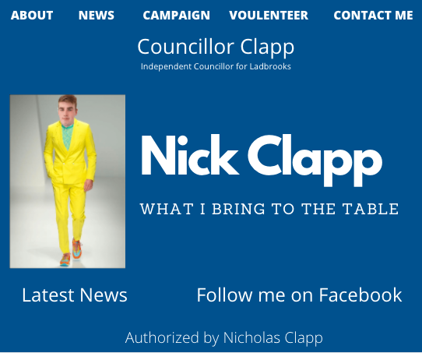

**Description**

This is my first design. It has the basics of what I want to achieve in my website by providing information about Councillor Clapp and having a simple nav bar making it easy for anyone to navigate their way through the site. It also has the information required to contact Councillor Clapp at any time. It has the use of blue which is a colour I like and works well with the site and the text colour.

**Feedback**

Hayden Riches: The banner should be a different colour to the background, too many different fonts. Likes the navbar. To Improve: Colour Scheme, banner, footer.

Mr Adams: A bit over the place. Could have the website title in the Nav bar. Could change the Follow me on Facebook to have the Facebook Logo.

**My Second Design**

**Description**

This is my second design. I have taken on the feedback about tidying the site up and not having the whole site being one colour. To achieve this, I have added images as well as an area that will be dedicated to a Twitter feed. This has been done without compromising the ability to easily navigate through the site for anyone who may wish to be looking at the website of Councillor Clapp.

**Feedback**

Hayden: Spacing is different on each edge. The black is impossible to read

Mr Adams: Use the rule of thirds, get the main image on the third line.

Have you considered doing a website that’s all on one page? Maybe put the ‘News’ in columns?

**My Third Design**

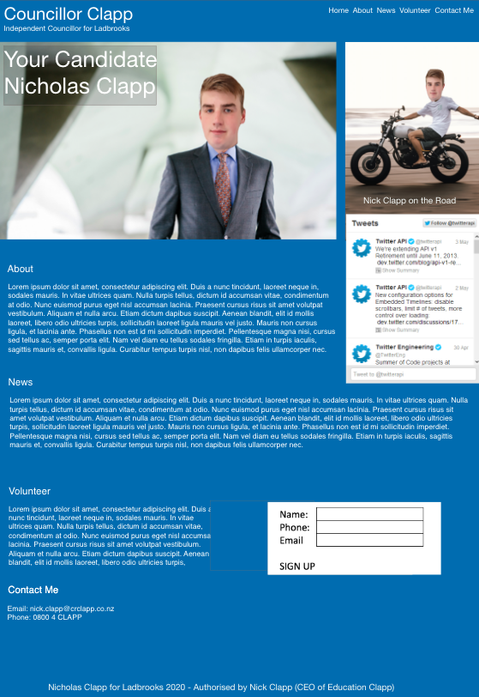

**Description**

This is my third design. I have incorporated the idea of having a single page website, where the nav bar links will send you a certain section of the page, and by scrolling through the website, you scroll through the different items on the nav bar. I have decided to do this to challenge myself and learn something new. I also added a Twitter feed and a sign up form for volunteers. I have also made the right-hand side image extend to the end of the site rather than leaving a gap.

**Feedback**

Hayden: The text could be a bit bigger, make the background colour white or grey. The nav bar is very good

Mr Adams:

**My Fourth Design**

**Description**

This is my next design. I have used feedback which has meant I have changed the layout slightly, so that all the next and information is on the left hand side, and photos and sign up forms are on the right hand side with the intention of making the site look tidier. Ive also added another image to avoid having a blank spot on the site without compromising the idea of the site being easy to use and not too much information overloading a users screen.

**Feedback**

Michael Longden: Your design is already very good. To make this design even better, I would suggest putting all your navbar links in a block link to increase the usability. I think the text under all the headings needs to be a bit bigger to help the people that struggle with reading.

Your log-in link at the bottom should be at the top with all the links in the navbar. As with your sign-up box down the side of the page, I think it would be better to put a Sign-Up link in your navbar to take users to a Sign-Up page. To promote Nicholas Clapp, there needs to be a paragraph about how he will run Ladbrooks and how people are going to benefit from him. Otherwise, why would people vote for him?

**Final Design**

**Authentication**

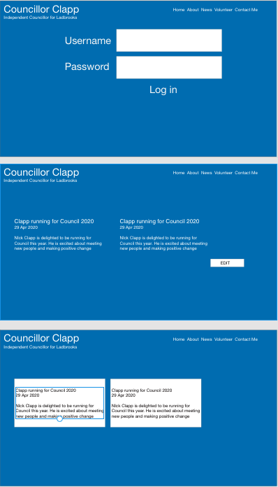

1. User logs on
2. The edit button then appears next to the news
3. The edit button will then take you to a page where you can edit the text

**Changes Made**

News Altering

One change I made was to have an admin panel to allow a logged in user to add or delete a news item, compared to having an edit button appear next to news. This means everything can be controlled in one place from the admin panel and made the idea achieveable.

|  |  |  |
| --- | --- | --- |
|  |  |  |

**User Testing**

Date: 3rd June

Name: Hayden Riches

Comment: Hayden tested the authentication system by entering in the admin page on the navbar (localhost/councilor/admin.php) to see if he could get to the admin page without logging in. He was able to, therefore I amended this with sessions so that if you aren’t logged in and you try to get to a authenticated users area, you are redirected to the home page.

Date: 8th June

Name: Leon Marsh

Feedback: I tested all elements of the site and everything works as it should. The formatting could be better though.

Date: 9th June 2020

Name: Genevieve Henstock

Feedback: I tested Nick Robins website and I thought it looked very professional, the only fault I found was when clicking the submit button on a form it submitted without needing to put the information in. but other that this I was very impressed with nicks effort.

**Conclusion**

Overall, I am very happy with the outcome of the Councillor Clapp site. I was pleased that I was able to use skills to add and remove items from the database through the website using SQL, and to make a site that closely matched my final design and that I was able to make it function the way that I wanted to. The disadvantage was I could not get a twitter embedment to work which left a blank blue space, which next time I would intend on coming up with a different option to fill this. Otherwise, I am happy with the site and believe it meets my intention of being easy to use by anyone including people who aren’t tech savvy. I also tried something new by having everything on one page, and the navbar then goes onto a specific part of the page when clicked. This works and I am pleased with the outcome on that front.

**Tools that made creating the site easier**

Screenshot – Trello

Trello allowed me to manage what I needed to do in order to build my site from start to finish including the designing. When building a website, there is a large number of things to get done so by using Trello, I could easily keep track of what was done and what was needed to be done. This made it easier because I didn’t have to write things down on paper which I could’ve lost.

I also used Adobe XD to design my site. This made building the website easier because I was able to design exactly what I wanted instead of using another site that wasn’t capable of the finer details that I required.

Overall, my website meets the specifications because it addressed all the relevant implications that were orginally set out: Usability, Legal, Ethical and Functionality. The site is usable by all age groups, and it does not matter on technical abilities because it is a basic site that can be easily navigated through and all information about Nick Clapp can be found. It does not break any legal laws, all images are either taken by Nick Clapp or are free to use images, nor is any text or content illegal and it all paints a good picture for the Councillor. The site is also ethical, meaning that it has no intent of offending anyone which is important since it needs to be friendly for anyone visiting that might vote for Nicholas Clapp. The final implication that I have addressed is functionality, which I have done through ways of keeping the site up to date and to work well. One way I have done this is the adding news/deleting news function in the admin panel. This allows an admin to add or delete a news item on the website without having to go into the database. This relates to functionality because it means the admins can easily update the site through the admin panel. The site is functional and the connecting to the database also functions well, including forms (volunteer and contact) that go to and store in the database and the news which can be added or deleted from the database. To summarize, the website meets all the relevant implications that I outlined in the plan which means the construction and final outcome of the site has gone to plan and I am beyond stoked with the outcome of it and that I was able to address all these implications.

The feedback I received on designs was taken into account and it was with the feedback that the site looks as it does, which is much better than what my initial design was going to look. The final feedback on User Testing was also very good, where the three people who tested my site (a mix of people with and without high end digital technology skills) were able to navigate through the site and use its functions easily. The feedback that was taken back is valuable as I was able to address some issues that have made the site work in a more professional manner, therefore was beneficial to gain the feedback.

To finish, I’d like to say how I have enjoyed the construction of this site and it has been very satisfying to see the skills I have learnt work well on the site. I was glad to address the implications and the feedback from others was very valuable to improve the site and the designs. I believe the final outcome of the site meets my goal of being able to showcase Councillor Nick Clapp to everyone with a site that is informative and professional without compromising usability.

**LOGON DETAILS**

Username: admin

Password: password